**Pre-Diagnosis Social Post Instructions**

Please use the following steps to share the

“Pre-Visit” post on your social media platforms.

**Step 1:**Begin creating your post by uploading the image provided in this   
document to the social platform of your choice.

**Step 2:**Copy and paste the statement in the box below into the caption section:

Have you noticed changes in your dog's activity and behavior? This easy-to-use checklist can help you spot the signs of osteoarthritis (OA) pain. Take the Canine OA Pain Checklist Quiz to learn more. https://bit.ly/3OFiYdC

**Step 3:**That’s it! Upload your post to help your clients learn about   
canine OA pain.

**Pre-Diagnosis Social Post Image**

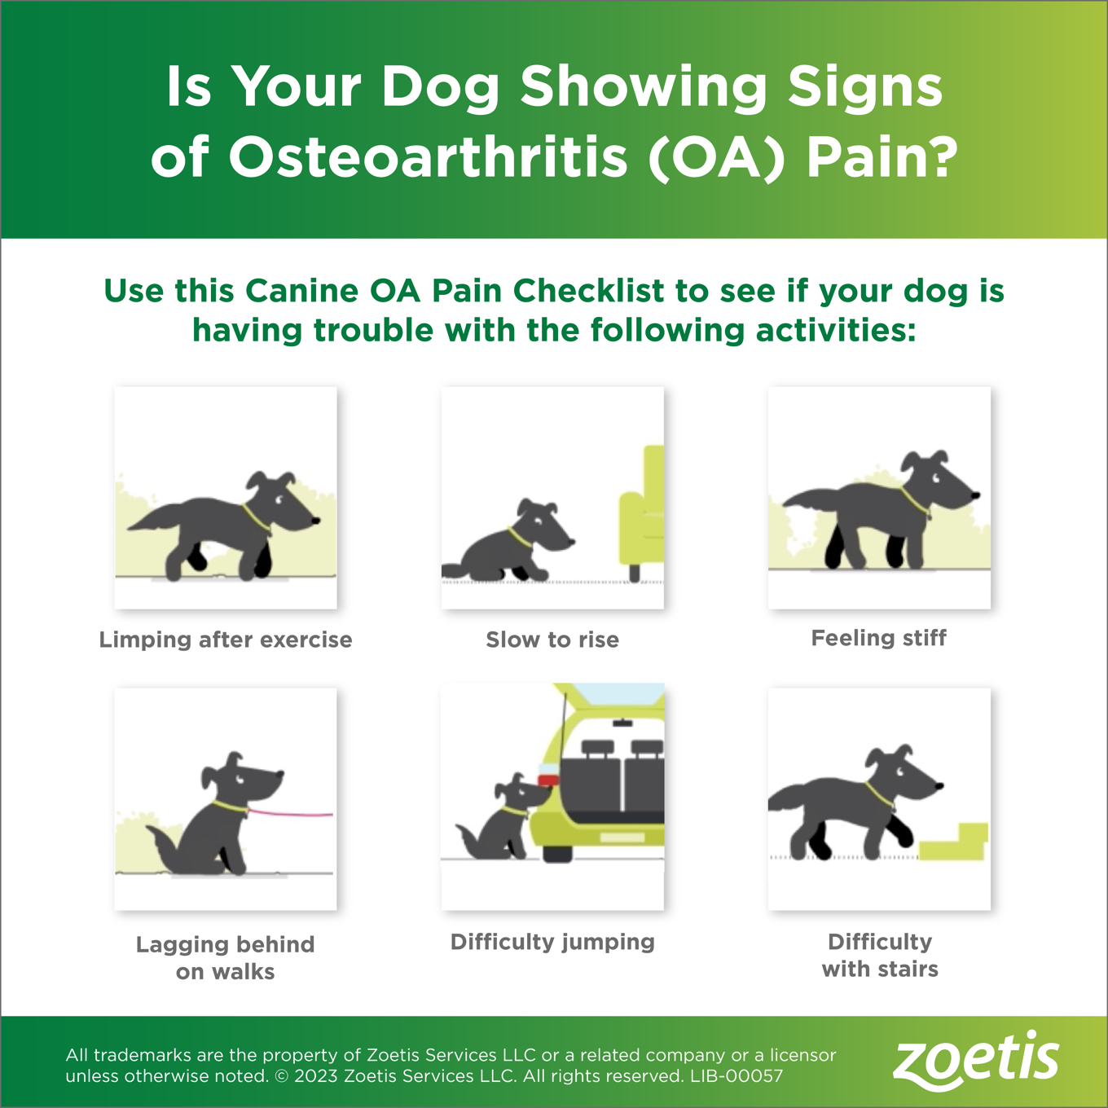

**Pre-Diagnosis Social Post Example**

Here's an example of what your post should look like:

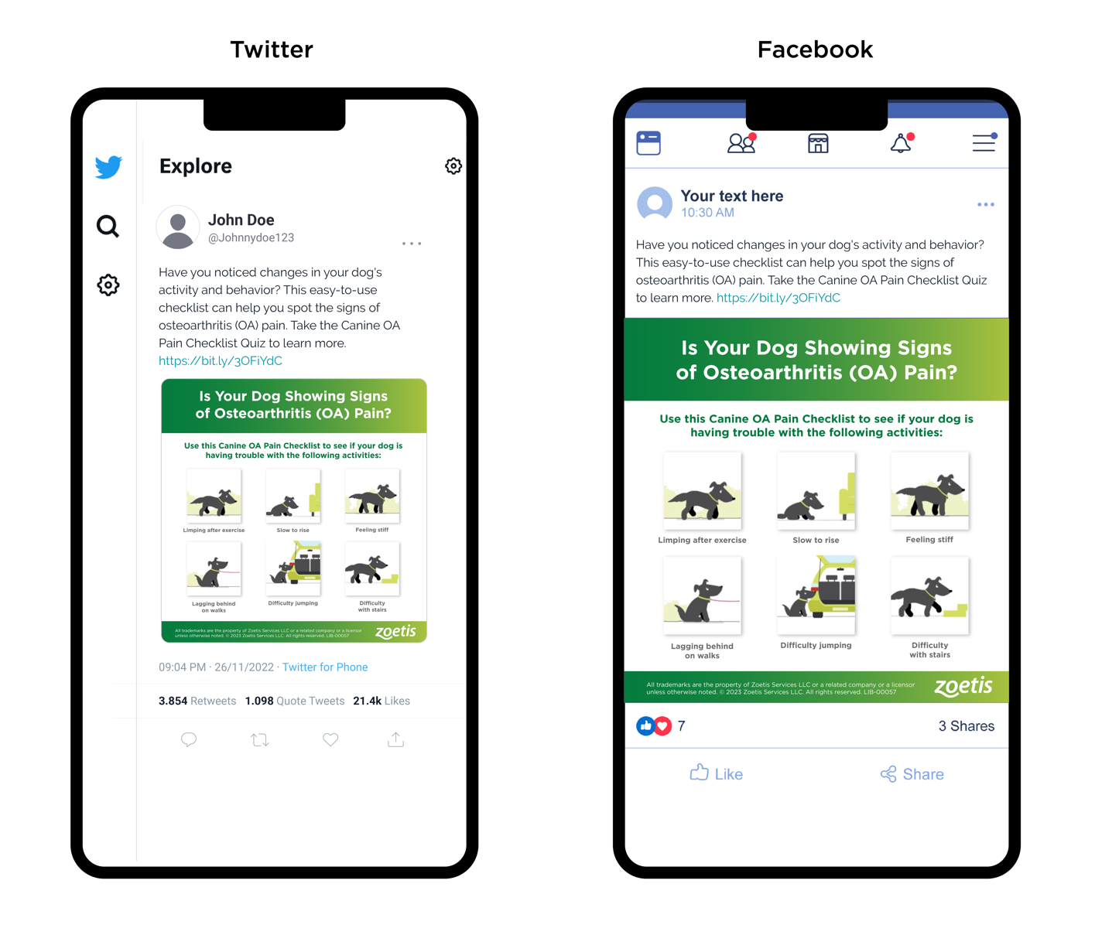

**\*NOTE: DO NOT POST THIS PAGE. THIS IS INTENDED TO SHOW YOU WHAT YOUR POST SHOULD LOOK LIKE.\***

All trademarks are the property of Zoetis Services LLC or a related company or a licensor

unless otherwise noted. © 2023 Zoetis Services LLC. All rights reserved. LIB-00057