LLC. All rights reserved. LIB-00058

**Tracking Progress Social Post Instructions**

Please use the following steps to share the   
“Ongoing Treatment” post on your social media platforms.

**Step 1:**Begin creating your post by uploading the image provided in this   
document to the social platform of your choice.

**Step 2:**Copy and paste the statement in the box below into the caption section:

See Prescribing Info: https://bit.ly/3snhsFq. While canine osteoarthritis (OA) isn't curable, Librela™ (bedinvetmab injection) can effectively control OA-related pain. Be prepared to share your dog's progress at your next follow-up appointment.

**\*YOU MUST INCLUDE THE BITLY LINK TO THE PRESCRIBING INFORMATION AT BEGINNING OF POST COPY\***

**Step 3:** That’s it! Upload your post to help your clients learn about Librela.

**Tracking Progress Social Post Image**



**Tracking Progress Social Post Example**

Here's an example of what your post should look like:

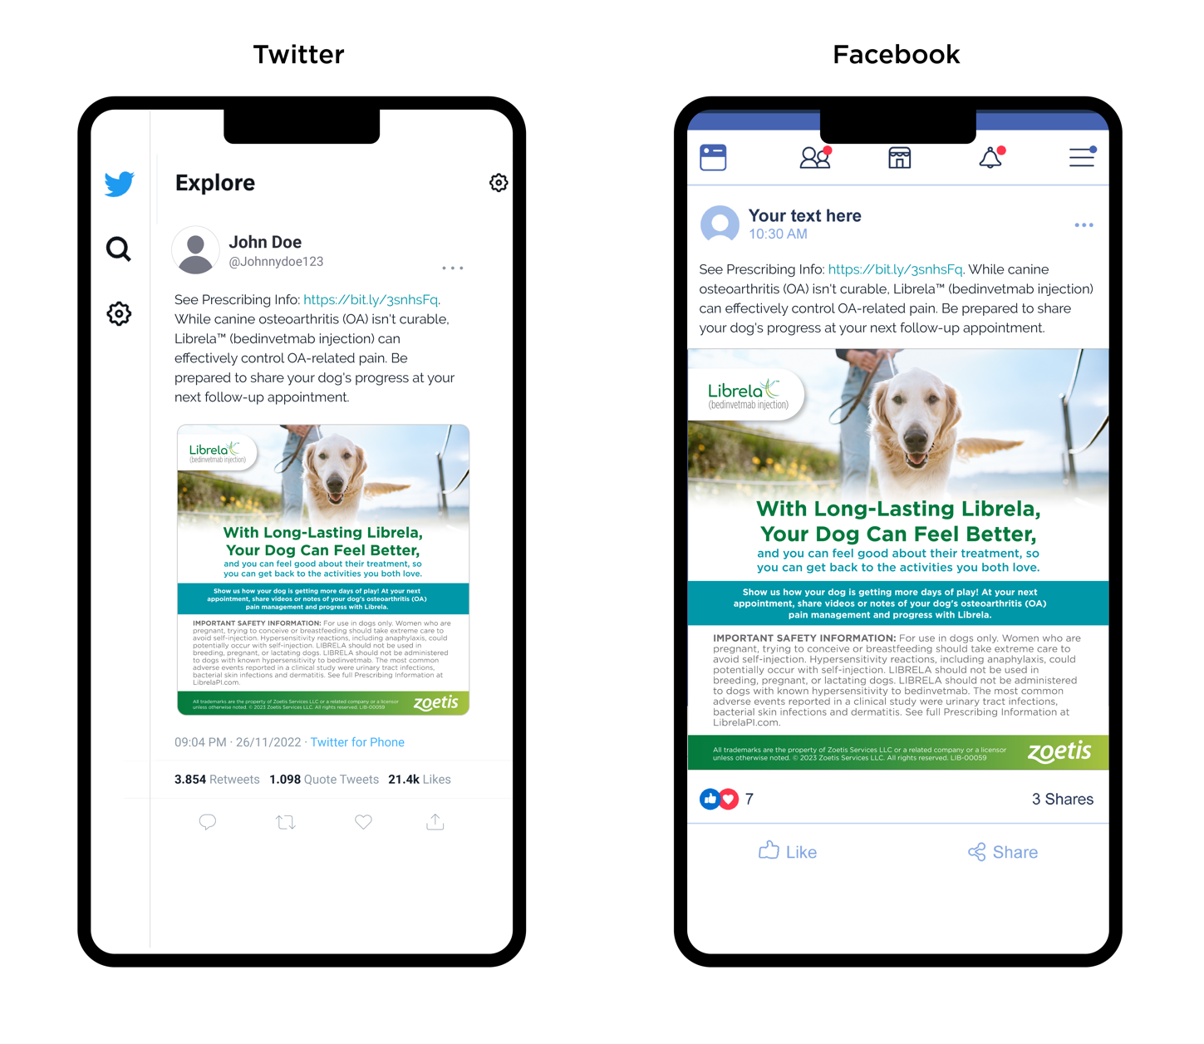

**\*NOTE: DO NOT POST THIS PAGE. THIS IS INTENDED TO SHOW YOU WHAT YOUR POST SHOULD LOOK LIKE.\***

All trademarks are the property of Zoetis Services LLC or a related company or a licensor

unless otherwise noted. © 2023 Zoetis Services LLC. All rights reserved. LIB-00059